# Media Analysis - No need to demonize ChatGPT but AI regulation is a must

## Short Summary

The article explores ChatGPT's development by OpenAI, emphasizing its multifaceted capabilities in generating diverse content and its implications for employment in the Saudi Arabian journalism sector due to potential job displacement.

## Summary

1. ChatGPT, a large language model developed by OpenAI, is being used extensively in journalism across various industries, including Saudi Arabia. Its ability to understand and respond to natural language makes it valuable for generating news articles, essays, reports, poetry, and scientific content with ease.  
2. The advent of ChatGPT has sparked discussions about its impact on education, journalism, and creative fields like literature. It challenges traditional teaching methods, raises concerns over plagiarism in journalism, and threatens jobs in medical writing and some forms of artistic expression.  
3. In the realm of education, universities are exploring ways to mitigate ChatGPT's potential negative impacts by introducing oral exams, handwritten tests, and more nuanced question formats. OpenAI is also working on technologies to detect AI-generated text, aiming to protect educators' academic freedom.  
4. While the medical field is seeing ChatGPT pass proficiency examinations like the US Medical Licensing Examination, healthcare companies acknowledge it will augment rather than replace human doctors in diagnosing and decision-making processes.  
5. Literature isn't immune to AI threats either; a California design manager used ChatGPT and Midjourney to create an illustrated children's book, leading to ethical and copyright issues that sparked protests from online artists. However, AI still has limitations such as making mistakes, getting confused with nuanced prompts, and generating outdated information.  
6. Despite the concerns about over-hype surrounding AI's impact on jobs, ChatGPT could potentially serve as an equalizer in science and other fields, providing resources to developing countries and individuals lacking access to traditional research means and data.  
7. However, without regulations, the imbalance might favor AI, leading to dire consequences. Therefore, it's crucial for stakeholders to implement guidelines ensuring fair use of AI technologies while mitigating potential negative impacts on human employment and creative expression.

## Question 1:

How do the media in this article frame the public discussion about ChatGPT? Are there certain **metaphors** that keep cropping up?

The media in this article frames the public discussion about ChatGPT using several metaphors, including 'revolutionary impact', 'disruptive force', 'equalizer', 'guardian of safe content', and cautioning against overhyping fear. These metaphors serve to highlight both the potential benefits and challenges associated with AI technology.

## Question 2:

Which role does or might the Arabic World play in the development of Artificial Intelligence? Answer with 'Not mentioned' if not applicable.

Not mentioned

## Question 3:

Which use cases of Artificial Intelligence are helpful for the Arabic world based on this article?

These are the key use cases of Artificial Intelligence as highlighted by this article that can be helpful for the Arabic world. They include journalism, education, the medical field, and even literature, though with limitations due to its inability to fully replicate human understanding or create truly original content.

## Question 4:

What is the final message of the article that the author wants to convey? Keep your answer short and precise!

The final message of the article is that AI's potential to benefit society while also posing challenges necessitates careful regulation to ensure its positive impact outweighs any adverse effects.

## Sentiment

The sentiment is 0

## Entities

New Technology Chatgpt View, Accord Axios Chatgpt, American Policy International Relation, Amal Mudallali, Url Https World Technology Advancement Arti Cial Intelligence, Newsroom, Washington Post Article Write, Chatgpt Midjourney Ai Program, Seattle Public School System Quickly Ban University College Fear Ban Ine Ective Raise Question Academic Freedom Busy Try Contain Chatgpt Potentially Negative Impact Education Change Mode Instruction Give Oral Exam Handwritten, New York Times

## Topic Clusters

### Cluster: ChatGPT Development

Development of ChatGPT technology, Advancements in AI language models, Innovations in conversational AI capabilities

### Cluster: Ethical Implications

Ethical considerations in AI development, AI and privacy concerns, Moral dilemmas posed by advanced AI systems

### Cluster: Societal Effects

Impact of ChatGPT on human communication, Changes in customer service due to AI advancements, Influence of AI on employment and job markets

## Word Clouds

### Wordcloud of content

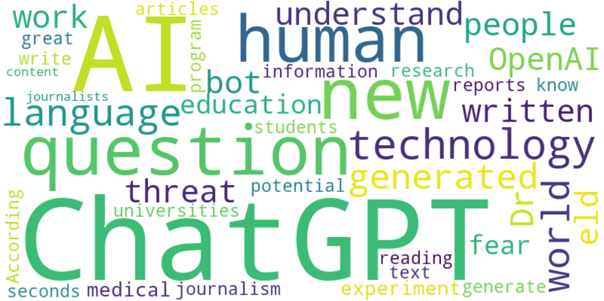

Top 10 words:

- ChatGPT: 28

- AI: 24

- human: 7

- technology: 6

- language: 5

- news: 5

- world: 5

- generated: 5

- OpenAI: 4

- understand: 4

### Wordcloud of summary

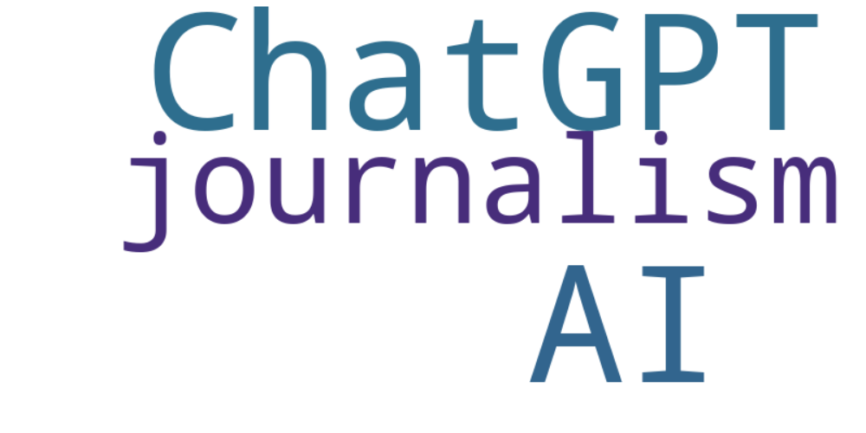

Top 10 words:

- ChatGPT: 6

- AI: 6

- journalism: 3